Question: Define favicon and give an illustrative example.

Answer: A favicon is a tiny icon included along with a website , which is displayed in places like the browsers address bar, page tab and bookmark menu.

It is usually of size 16 X 16 px an stored in Gif or png format.

Example:

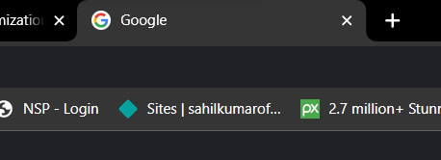

Above image is the example of favicon of google website